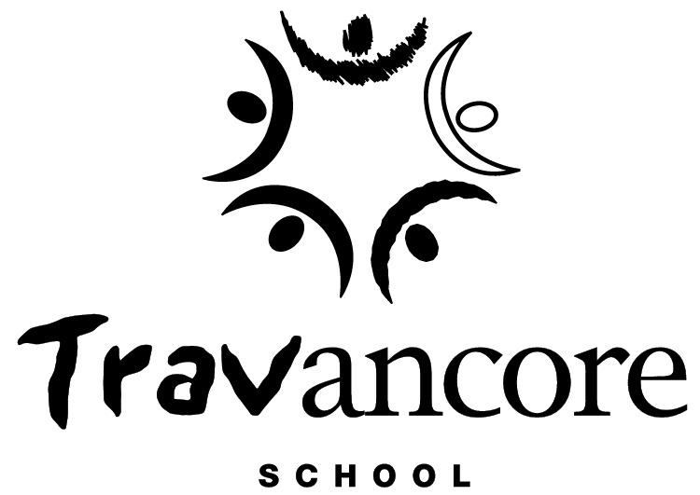

Photographing, Filming and
Recording Students at the Travancore School

Parent/Carer Consent Form

During the school year there are occasions or events where staff may photograph, film or record students participating in school activities and events. We do this for many reasons including; to celebrate student participation and achievement, showcase particular learning programs, document a student’s learning journey, camps, excursions, graduations and to communicate with the school community.
This notice applies to photographs, video or recordings of students that are collected for the purpose of publication, production and presentation.
We ask that any parents/carers or other members of our school community photographing, filming or recording students at school events (e.g. school graduations) do so in a respectful and safe manner and that any photos, video or recordings ‘images’ of students are not publicly posted (e.g. to a social media account) without the permission of the relevant parent/carer.
If you do not understand any aspect of this notice, or you would like to talk about any concerns you have, please contact our school on ph: 9345 6051 or travancore.sch@edumail.vic.gov.au

Use or disclosure within the school community
Unless you tell us otherwise, images of your child may be used by our school within the school community, as described below.
Photographs, video or recordings of students may be used within the school community in any of the following ways:
- in the school’s communication, learning and teaching tools
- for display in school classrooms
- to support student’s health and wellbeing (e.g. Anaphylaxis plans)
- graduations/celebrations

We will seek additional consent if we are considering using any images of your child for specific production or publication purposes.

Privacy
Photographs, video and recordings of a person that may be capable of identifying the person may constitute a collection of ‘personal information’ under Victorian privacy law. This means that any images of your child taken by the school may constitute a collection of your child’s personal information. The school is part of the Department of Education and Training (the Department). The Department values the privacy of every person and must comply with the Privacy and Data Protection Act 2014 (Vic) when collecting and managing all personal information. For further information see Schools’ Privacy Policy (http://www.education.vic.gov.au/Pages/schoolsprivacypolicy.aspx).

Ownership and Reproduction
Copyright in the images will be owned by the school. This means that the school may use the images in the ways described in this form without notifying, acknowledging or compensating you or your child.
Consent

Travancore School understands that parents and carers have the right to withhold permission for our school to use photographs, video or recordings of your child (apart from circumstances where the school is not required to seek consent as outlined in the Travancore School Photographing, Filming and Recording Students Policy located https://www.travancoresch.vic.edu.au/school-policies)

Parents/Caregivers are able to change their mind about consent at any time and can do so by contacting the Travancore School Principal travancore.sch@edumail.vic.gov.au

- I have read this form and I consent to Travancore School using photos, video or recordings of my child (named below) to appear in the following ways:

- Use within the school community (e.g. in the school’s communication, learning and teaching tools, on display around the school)

- I have read this form and I do not consent to Travancore School using photos, video or recordings of my child (named below).

Name of student
Name of parent/carer
Signature
Date

*Please note that it may not be possible for the school to amend past publications or to withdraw images that are already in the public domain.

